8. Comment Maintenance

Table of Contents
Comment Maintenance 2
Creating a Comment 3
Editing a Comment 4

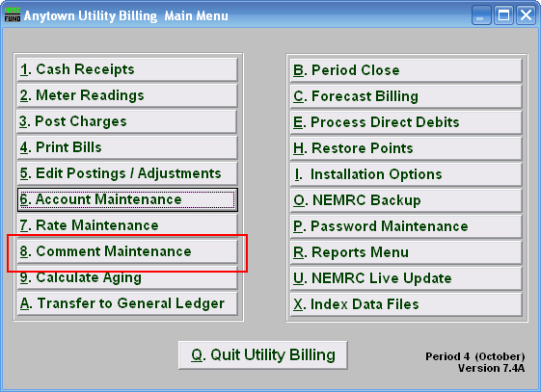
Click “8. Comment Maintenance” off the Main Menu and the following window will appear:

Comment Maintenance

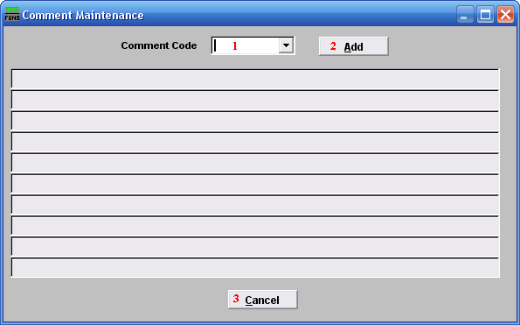
- Comment Code: If you want to edit a comment that already exists, type the code into this field, or use the drop down arrow and select it from the list of comment codes.

- Add: Click “Add” if you want to create a new comment. The below window will appear.

- Cancel: Click “Cancel” to return to the Main Menu.

Creating a Comment
If you choose “Add” from above, the following window appears:

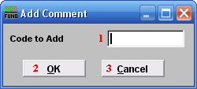
- Code to Add: Type the code for the comment you are going to create. This is the code that will be used to apply or edit this comment. Example: COMM4

- OK: Click “OK” to move on and edit the comment for this code.

- Cancel: Click “Cancel” to cancel and return to the previous window.

Editing a Comment
Once you’ve created or chosen a comment, the following window appears:

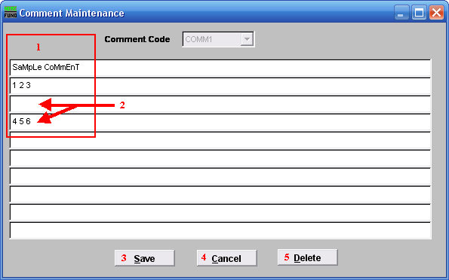
- Type the code EXACTLY how you want it to appear on a bill.

- If you skip a line, anything below a blank line will not appear on a bill.

- Save: Click “Save” to save this comment to this comment code.

- Cancel: Click “Cancel” to return to the previous screen.

- Delete: Click “Delete” to delete this comment code and return to the previous screen.

